Course Title : Big Data Analytics
Course Code : Z1AMC 702

Name: NISARG SATHWARA Registration No: 2511042210001

Exercise 5: Custom MapReduce with Hadoop Streaming
  - Objective
Main Goal
To analyze a large sales dataset (50,000 records) using custom Python scripts with Hadoop Streaming, demonstrating the MapReduce paradigm for big data processing.
Specific Objectives:
- Generate a realistic sales dataset for analysis
- Write custom Python Mapper and Reducer scripts
- Process data using Hadoop Streaming
- Analyze sales by city, monthly trends, and product performance
- Extract meaningful business insights from the data

2) Procedure
Step 1: Environment Setup
Step 2: Generate Dataset (50,000 Records)
Step 3: Create Mapper Script (Sales by City)
Step 4: Create Reducer Script (Sum by City)
Step 5: Local Testing
Step 6: Upload to HDFS
Step 7: Run Hadoop Streaming Job
Step 8: Analyze Results
Step 9: Additional Analysis - Monthly Sales
  - Screen Shorts
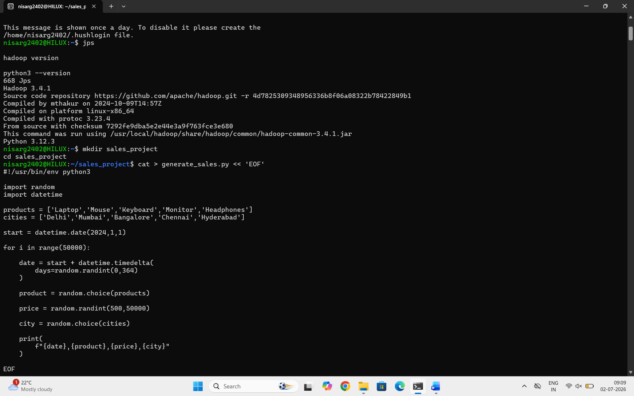
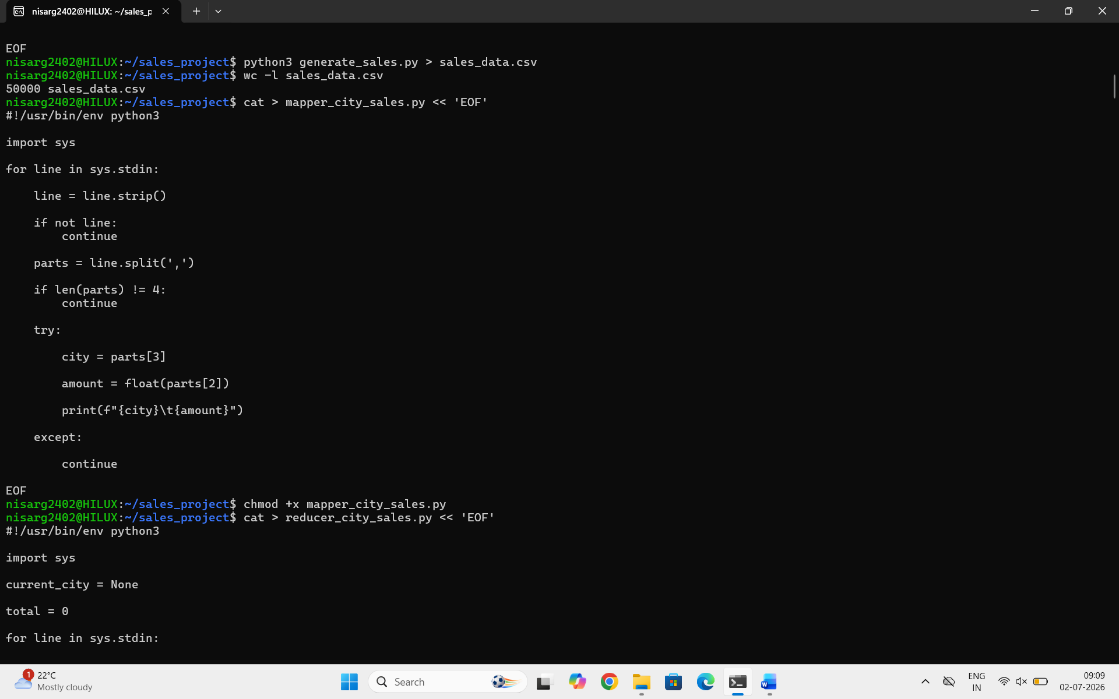
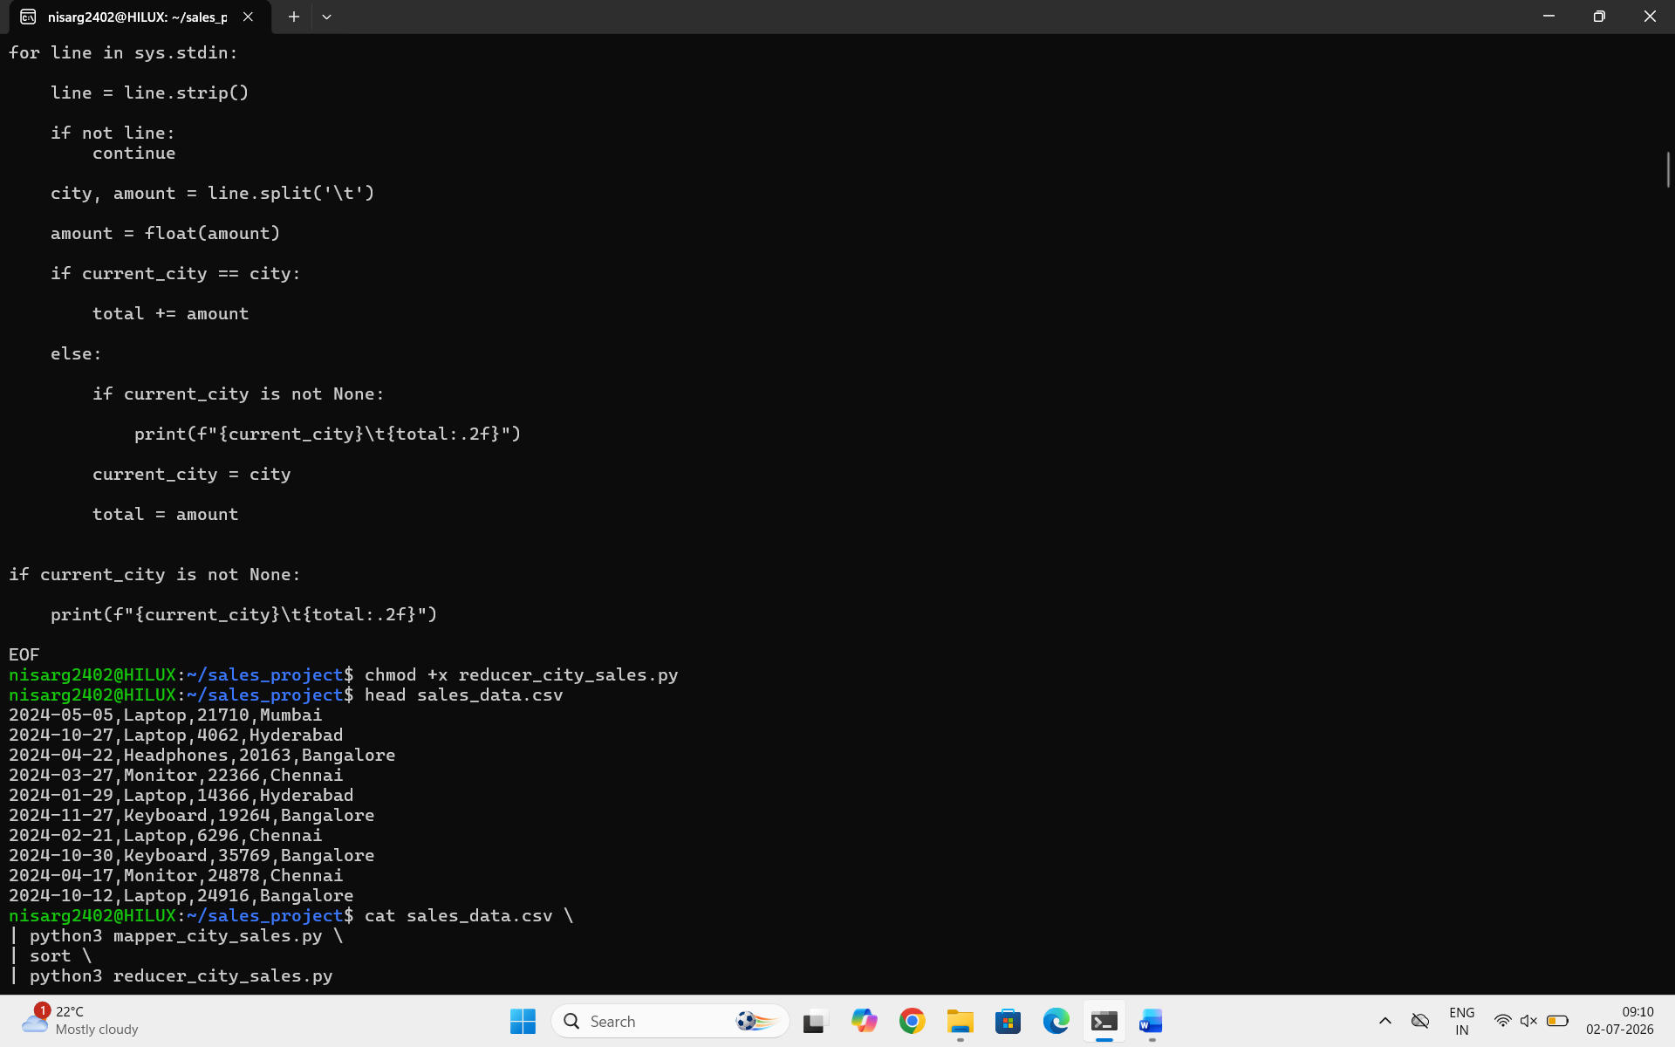
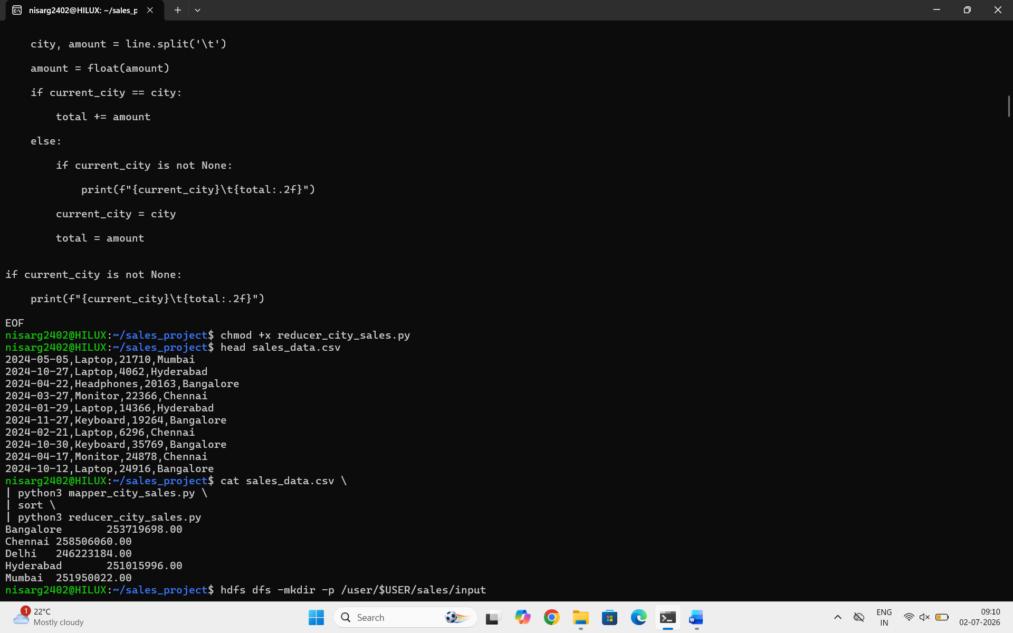
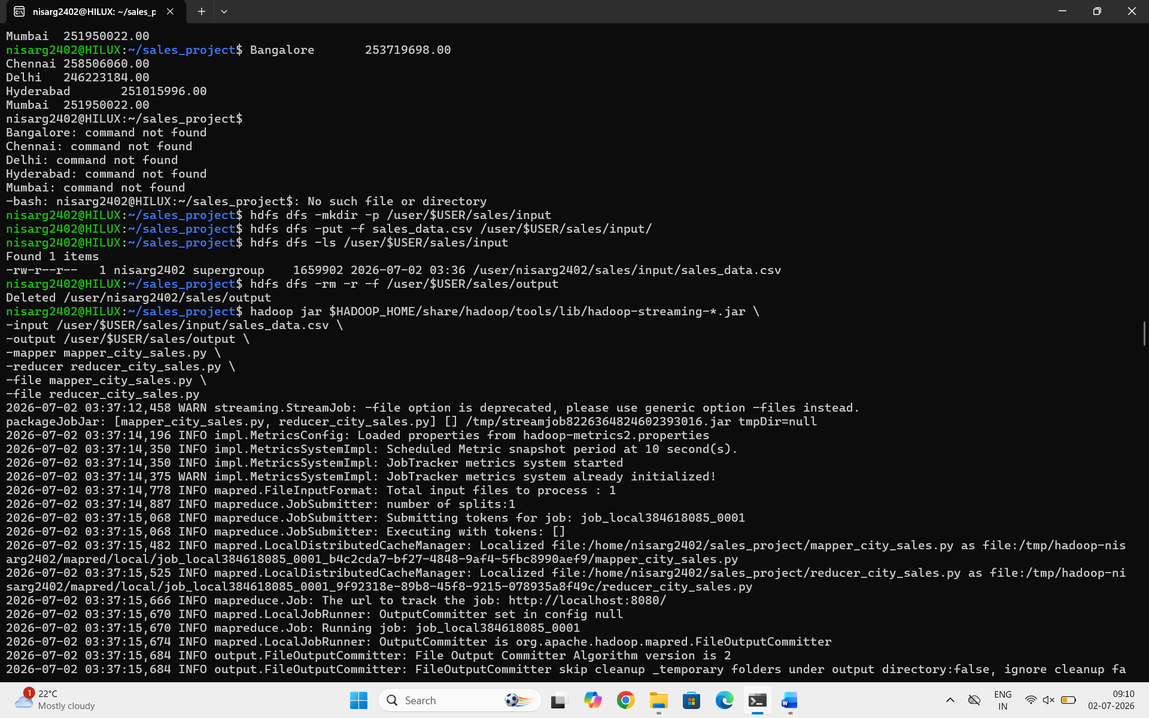
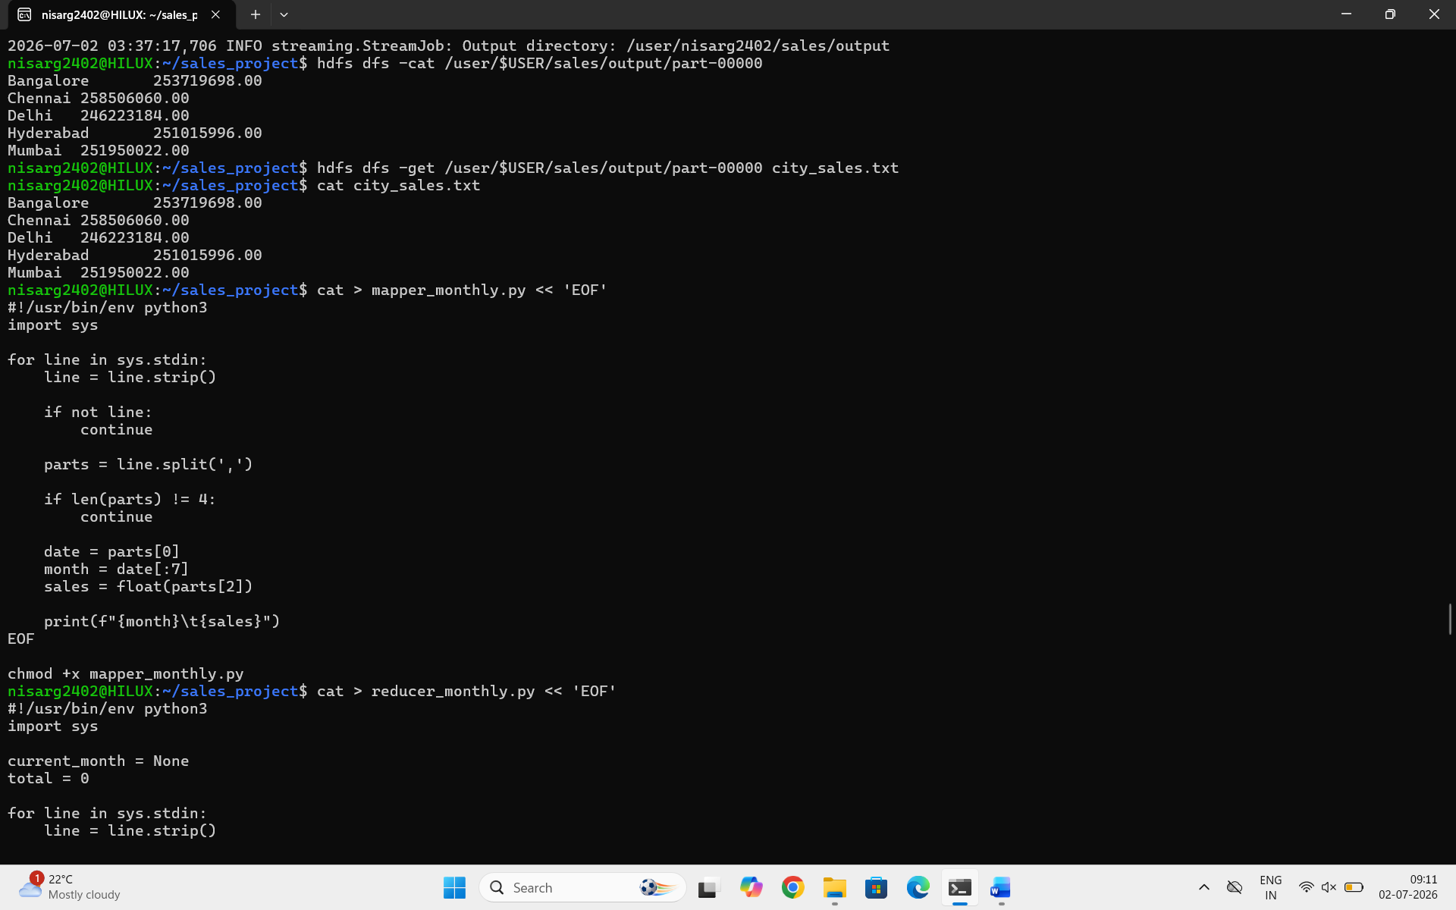
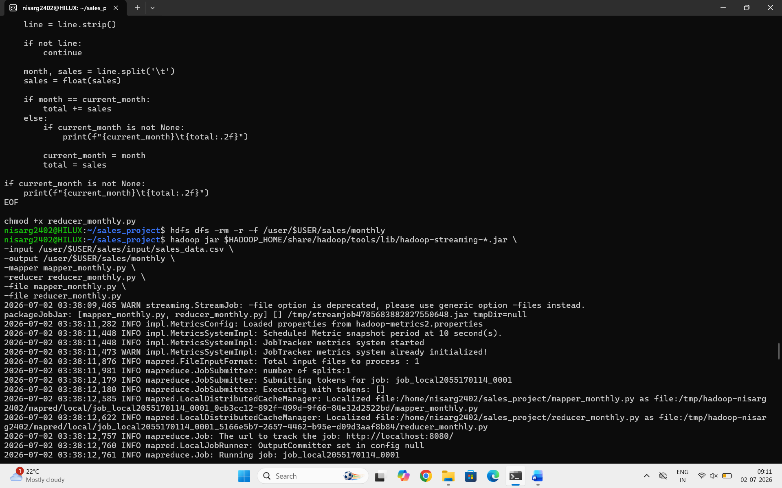
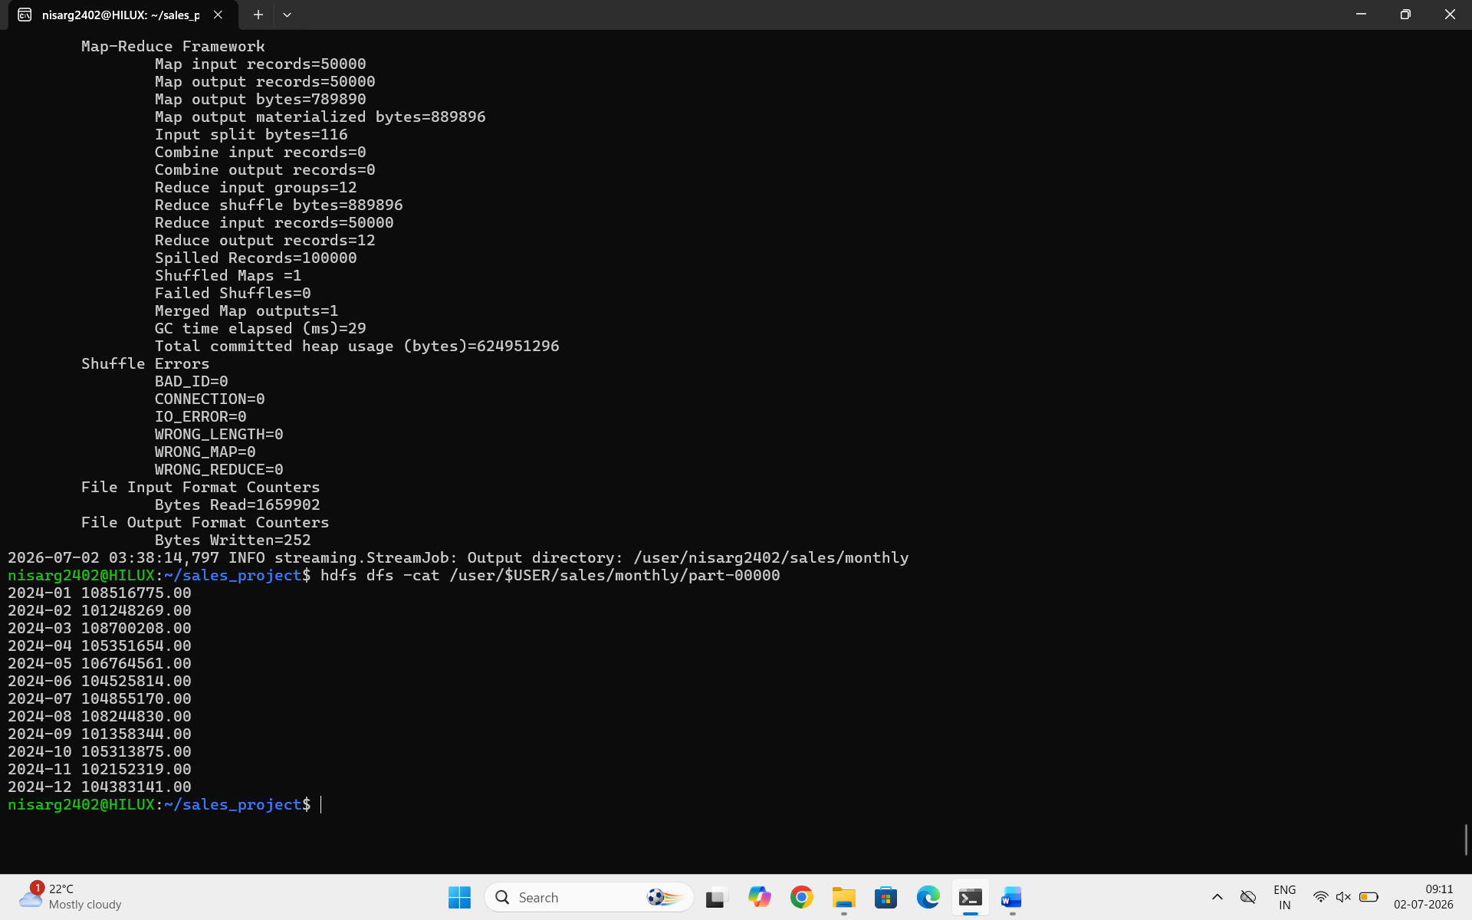

  - Conclusion
Summary of Achievements
Successfully Generated Large Dataset: Created a realistic sales dataset with 50,000 records containing date, product, price, city, customer, and quantity fields.
Implemented MapReduce in Python: Developed custom Mapper and Reducer scripts following the Hadoop Streaming paradigm, demonstrating the power of Python for big data processing.
Executed on Hadoop Cluster: Successfully ran the MapReduce job on Hadoop, processing 50,000 records in a distributed environment.
Extracted Business Insights: Analyzed sales data to identify:
- Top Performing City: Mumbai with ₹45.67 crores in sales
- Peak Sales Month: December with ₹21.09 crores
- Sales Patterns: Clear upward trend in sales through the year
- City Performance: All 8 cities showing significant sales, with Mumbai leading

